Introductory notes

Purpose of this document
This document serves as...
- A guide to developers as to the final features desired.
- Documentation useful to orient new developers to the code-base.
- A source-document to draw on to develop user-friendly help files and tutorials

As such, please ensure you update this document any time a change in the project’s functionality is made.

Legend to this document
Yellow highlighting: Sections of Incomplete documentation
Black text: These features do not exist yet.
Blue text: These features have been implemented.
Red text: Group decisions need to be made about this issue before development can commence
Green Text: Documentation relating only to the discontinued AU PHP Movement tracker development branch (included to assist developers in successful porting. Please delete once they have served their purpose)

Big idea
The MT does many things, but in general they can be summed up by 1 or 2 “big idea” visions.

- Campus staff are busy. They want to do face-to-face ministry. As ministries become movements though, they become large, unwieldy and hard to track. If they didn’t, they’d likely still be just called ministries. The Movement tracker acts as a full-time Personal Assistant attached to each campus. It takes on the primary responsibility of determining who the leaders are, who they meet with, and what their sub-leaders are up to as well. It delves down mapping out the entire discipleship tree for a campus. Then it takes on the job of periodically contacting these members to ensure it can keep important information about them and their groups up-to-date. This can save hours of campus staff time – leaving them free to focus on the main thing, doing face-to-face ministry.
  - Some applications:
    - It annually confirms it has the correct semester dates for a campus from the leaders. As the semester begins, it asks these leaders who their bible study group leaders are. It then contacts these bible study leaders periodically through a semester giving them a report of who the MT knows is a member in their group and asking if any newcomers have joined who are not on the list – for missing members it simply asks for their first name and email. The MT then contacts these members directly asking for their timetable and contact details.
    - It collects timetables from all members at the beginning of each semester. It provides functionality to compare timetables for a selection of users to find a suitable group time. It then offers to email these members to inform them of the newly chosen group time – allowing the leader to add a personal introduction to the email.
    - Prior to a semester starting, it contacts leaders giving them a list of users under their care and the role status currently assigned to them. It allows the leader to promote members to a higher status (eg from “Student Involved” to “Student Leader”), archive a member (with a reason given: “Graduated”, or “No longer involved”, or “Other”)
    - Portal system controlling authorisation to various other CCC webservices
- A movement tracker allows Campus Coordinators and Regional leaders to gain an overview of what is happening in their regions
  - Provides real-time accurate statistical summaries
  - Provides dynamically up-to-date lists of all staff, all student leaders, all CCC members for any given region
  - Provides something akin to an HR system for ministry contacts, contact details, possibly even emergency contact details which could be used in the case of an emergency.

Terminology & Concepts

RP
Every user has one RP (Responsible Person), never more, never less. They may be their leader, mentor, discipler, or just someone who has been assigned to be their main contact person. The idea is that when the MT has problems contacting a particular user, the RP is the person it turns to next to decide what to do with them. Usually it is the RP who promotes a user over time. If an RP is archived, then there will need to be some system for re-assigning their users with a new RP.

We will not allow for a user not to have an RP, unless they are an admin. Hence, all MT modules can assume there is an RP who can be contacted. In the case of admins, if they have no RP listed, we should list themselves as their own RP. A national director should either have an admin as their RP, or be given admin role so they too can be self-refering.

Resolving RP vacancies when a user is archived
(see also resolving campus contact vacancies for a similar topic)
In order to ensure all leaders have an RP, we need a resolution system for when a user disappears from the system.

Assume A is RP for B who is RP for C1,C2, and C3.

If B graduates, then C1,C2,C3 will have A now assigned as their RP, and a notification sent to A of this action.
If B does not have an RP (ie there is no “A” user, “B” being the top of the discipleship chain) then C1,C2,C3 are assigned to the campus contactof the current campus or region. Campus contactrules enable the resolution for cases where C1,C2, or C3 happen to already be top leaders for their region.

There may be situations where “B” was the campus coordinator. It wouldn’t make a lot of sense “A”, the regional director, to now inherit a bunch of students they have never met. Hence, when a user is about to be archived or deleted, we should have a popup box that outlines the RP reassigning actions that are about to take place, giving the option to proceed or cancel. This will give the user a chance to first re-assign these users to another missionary on “B”’s campus before they archive/delete “B” from the campus.

There should be some method for a user to transfer a user under their care to a new RP. A notification email will be sent to inform the accepting user of the transfer.

Users can’t alter their own RP, but it is visible somewhere on their profile, and editable by leadership.

Confirmations
A number of actions require confirmations by more senior users before they are completed (e.g. see Promoting users). This is done by firing off an email with the confirmation request. (see unresolved action notifications). These would be handled as a correspondence.

Promoting users
A user is assigned a particular role on the confirmation of their registration. Roles control the permissions that a user has within the MT. Students will go through the role stages of “Student” -> “Involved Student” -> “Student Leader” -> “Ministry Leader”.

A user can only promote another user they have permission over to a status equal or lower than their own level (ie “missionary” can promote up to “missionary”). If the user tries to promote another to their own level, it fires off a notification to the initiating user’s RP informing them of the action, giving a safety mechanism whereby the RP may reverse the action.

Unresolved action notifications
A user may have a number of actions requiring their attention piling up. How to ensure they don’t get lost in their email inbox?
- The dashboard of the MT could have a widget to list all the unattended to notifications.
- Every time a new notification is sent out, the bottom of the email contains a 1-line summary per other actions also requiring attention with a hyperlink to each. When the user logs in to the MT, the homepage could also have a list of unattended-to notifications. Also, the Overdue and Expiry actions for various correspondences will help track down inactivity by users.

See also Action to take when notifications are not attended to.

Modules

Correspondence module
The correspondence module handles all individual email-outs, or potentially other correspondence types (eg SMS, Facebook messages).
The concept is that as the MT actively contacts users to maintain the validity of data over time. The correspondence module tracks what communications have begun and information about them.

Correspondence types can be initiated in one of two ways:
- A module initates it in response to an action by a user (e.g. When they register a new account claiming to know leader X, the MT emails X with a correspondence type “PleaseVerify”)
- A “InitCorrespNOW” task can be registered in the taskscheduler’s database (tablename “task”) for a particular date. On that date, the taskscheduler would initiate a correspondence of the kind requested (e.g. One month before a campus semester begins, the MT emails campus coordinators asking them to check that the semester dates in the MT are accurate). “InitCorrespList” tasks are similar, but they will initiate a correspondence of that type to every member of the specified list.

If your correspondence involves responding by your user, then the .ini file will point to a RedirectModule. Write the module action and template to handle responses from the user.

When a correspondence is initiated:
- The .ini file is loaded
- The correspondence is registered in the database, returning a receiptID
- The email is compiled, by creating mailmerge tokens and inserting them into the email’s template
- The email is sent
- Any task actions associated with this stage are executed.

How redirection is done
The receiptID embedded in the URL of the correspondence will retrieve the correspondence record in the database. This record will load any stored variables (see the .ini file entries entitled "Generic1" and "Generic2") into options, then call SGL_HTTP::redirect($options)

Correspondence states
Correspondences live in one of three states:
- NOW (when the correspondence is first initiated)
- OVERDUE (after a predetermined time, it is considered overdue which may lead to further action by the MT to try to gain the attention of users who have not replied)
- EXPIRED (A predetermined time for which it will be assumed the user is not responding. Alternative action may be needed)

Overdue correspondences
Overdue correspondences usually lead to a reminder email being sent to the user.

Certain confirmation types warranting urgent attention might be suitable to pass up the line – ie send it to the un-answering user’s RP as well (either user can now answer the notification), letting them know that it is a forward (ie “I am forwarding you this confirmation request because Bill hasn’t responded to me about it for the last 10 days. If you could provide a decision, that would be helpful.”)

Expired correspondences
Expired correspondences are removed from the system entirely. This might be invitations that expire, or requests that become so old as to become irrelevant.

Determining if a correspondence has been answered
Each correspondence has a “Submitted” and “Visited” datestamp field associated with it. Visited records when the hyperlink embedded in the correspondence email was last accessed. Submitted records whether the correspondence was successfully completed.

It is actually quite difficult to tell definitively if a correspondence has been answered. We can tell if the link in the email has been followed, and if it leads to a unique form that can only be accessed by the correspondence then we can tell if the results have been submitted. This is currently the definition of a successfully completed correspondence.

Unfortunately, some forms can be accessed without the correspondence link being followed. For example, a correspondence asking them to update their timetable uses the standard timetable form. The user could have decided to log in normally, and updated their timetable the usual way. In this case, I suppose we could check when the timetable record was last updated by the user and conclude implicitly that the correspondence has been completed.

More difficult again though is a situation where-by the correspondence might ask them to check that their contact details and phone number are correctly entered. In this case, the user might log in normally, check the details, and decide they are still right so make no edit action at all. Or even more inconveniently, the user knowing no personal details have changed in the past two years doesn’t even bother to log in at all.

Users can set their unattended to correspondences to “submitted” by checking them off on the unattended to actions list that may appear on the homepage.

Correspondence table
/*==============================================================*/
/* Table: correspondence */
/*==============================================================*/
CREATE TABLE if not exists correspondence (
`ReceiptID` varchar(10) NOT NULL default '',
`Type` varchar(30) NOT NULL default '',
`Visited` date NOT NULL default '0000-00-00',
`Submitted` date NOT NULL default '0000-00-00',
`TargetID` int(11) NOT NULL default '0',
`Generic1` int(11) NOT NULL default '0',
`Generic2` int(11) NOT NULL default '0',
`Issued` date NOT NULL default '0000-00-00',
`Expiry` date NOT NULL default '0000-00-00',
`Overdue` date NOT NULL default '0000-00-00',
PRIMARY KEY (`ReceiptID`),
Index (`TargetID`)
) TYPE=MyISAM COMMENT='Tracking outstanding Correspondences';

- ReceiptID: Each correspondence has a unique receiptID and hyperlink associated with it which is embedded in the email correspondence sent out.
- Type: The type of correspondence
- “Visited” –If the user responds to the link by clicking on it, “visited” records the last date the link was clicked on.
- “Submitted” – records if the link was not just clicked on, but the resulting page requesting for action was then completed and processed. If a submitted date is recorded, then the correspondence has been satisfactorly dealt with and closed. The record entry will remain in the database table for the sake of reports issued to leaders, but will eventually be purged from the table.
- “Overdue” and “Expired” are dates set on the creation of the correspondence and indicate by what date this correspondence should be considered “overdue” or “expired” if no response has been received (ie when a followup action needs to be taken due to a lack of response from the user)
  - On “Overdue” date occurring, a followup action may be to send a reminder email to the user.
  - On “Expired” date occurring, a followup action may be activated like informing their RP that this person needs to be followed up by a phone call (e.g. “Bob has not replied with his preferences for bible study groups this semester. Would you like to call him directly?”). Often the correspondence is then purged from the table.
  - Staff and student leaders should be able to view summary reports for users they are responsible for (e.g. “These 10 ppl have confirmed their contact details for this year, these 2 people have not responded – I will try contacting them again in 1 week, otherwise you may like to contact them directly”)
- “TargetID” records the user who is the target of this correspondence
- “Generic1” and “Generic2” are flexible storage slots used differently for different kinds of correspondences (eg it may record the GroupID of the small group that a user is being invited to join)
- “Stage” – this variable should record what state the correspondence is up to to ensure that the OVERDUE actions are executed just once.

Correspondence types
There are a number of correspondence types (currently located in the modules\correspondence\classes\Types directory).
Each type has the following files associated with it:
- SampleType.ini – provides data about this correspondence type (see correspondence type .ini files)
- SampleType_NOW.html – email template used immediately when this correspondence type is initiated. HTML version.
- SampleType_NOW.txt – text version of the above (see Emailer library)
- SampleType_OVERDUE.html – template of email sent out when this correspondence type is overdue
- SampleType_ OVERDUE.txt
- SampleType_EXPIRED.html - template of email sent out when this correspondence type is expired
- SampleType_ EXPIRED.txt
- SampleType_UPDATE.html – template of email sent out to leaders to update them on which users have so far responded to this correspondence type. (For example “here is a list of users who have so far responded to update their personal details, and here is a list of those who have not”)
- SampleType_ UPDATE.txt

The various Correspondence types in existence are:
- “LeaderCreatedYouAcctPlsVerify” – When a leader enters a new user into the database, this correspondence is used to contact that new user and ask them to verify their desire to join the campus ministry online community (in particular, the online registration process asks for them to agree to the privacy policy).
- “PleaseVerify” – When someone creates a new account for themselves on the MT, this correspondence contacts the leader they claim can verify their identity. It asks the leader to confirm the email address as belonging to the person who is claimed.
- “PleaseVerifyUnconnected” – When someone creates a new account for themselves on the MT and says they don’t know any user from their campus, this email is sent to the campus leader. It asks the leader to call, meet, and verify the user.
- “HasBeenVerified” – Informs the new user that the leader has successfully verified their account
- “Approval Rejected” – Informs the user that the leader has been unable to successfully verify their account. Asks them to personally contact the leader to jog their memory of who they are. If they are unable to do this, we assume they don’t really know the leader as they claimed.
- “AskForBiblestudyLeaders” – Asks the campus leaders who will be bible study leaders this coming semester using the “Quick group add” form.
- “CGVisitor” – Invites a new Core Group (bible study) member to fully register on the MT, selling it as “membership” to the group.
- “RoleUpdateAssignedContacts” – Asks an RP to review a list of the people they are responsible for and gives them an option to promote them to a higher role, or to mark them as “disappeared” or “graduated”
- “SemesterDate” – Asks the campus leaders to clarify what dates the next semester begins, and when it should start asking students for their timetables.
- “UpdatePersonalDetails” – Sent to users at the beginning of a new semester, asks them to check that their contact details are up-to-date, and asks them to enter their timetables. It would be great if it included basic contact detail information (e.g. phone numbers, email, address) in the email so the user can be alerted if this is a priority issue for them.
- “UserStatusChanged” – Informs the user that another user has altered (usually promoted) them to a new role. Also lets them know of any additional features that have been enabled as a result of this role change. It would be good to have a unique function in the roles manager that checks what possible new features have been enabled and creates these notifications on the fly to be included in this mail-out.
- “VerifyEmailChange” – Changing email address involves confirming with the new destination email address that this is indeed what they intend. This email is sent to both the new and old email address asking them to confirm the change via a provided link (handled by the _cmd_rcpt function).
- “WhoAttendedYourGroup” – Sent periodically to bible study leaders throughout the semester, it provides a list of people registered on the MT for their bible study group and asks the user to follow a link to add any users not currently on the list. The link goes to a “Quick add” form of the Groups module.
- “YouHaveBeenAssignedGroupLeadership” – As a followup from the “AskForBiblestudyLeaders” correspondence type, this email now informs a user that they have been assigned as a group leader.

The current method of multiple files associated with each correspondence type sitting in a directory I think is messy. It would be great to eventually move these into a database and allow a super-user to edit the templates and associated configuration files online. The business logic behind each correspondence type obviously needs to be hard-coded, so creation of new types would be a programmer’s job, but customisation of them could be done by certain users.

Correspondence type .ini files
Contains date for each correspondence type:
- What the email’s subject header should be
- How many days must transpire before a correspondence should be considered overdue, or expired
- What action to take when an email is overdue, ie which module and manager to call.
- Which task manager actions to activate when OVERDUE status is reached, and whether any additional Correspondences should be fired off at this stage.
- Which task actions and correspondences to initiate as a followup action when the target user has responded to this correspondence system.

These all relate to the business logic system for correspondences and tasks

Key functions of interest

function initiate($input, $stage = 'NOW')
// WHAT:
// Initiate a correspondence between the database and target users
// Either an initial (NOW) correspondence or a overdue reminder (OVERDUE)
// INPUT:
// $input requires 'TargetID', 'correspType'. Can also include:
// 'SenderID', 'group_id', 'CampusID',
// $stage = the correspondence stage (NOW, OVERDUE, UPDATE)
- This begins the whole correspondence business logic flow.
- Initiates a new correspondence, either of NOW or OVERDUE type
- Reads the ini file
- If “NOW” type
  - Registers correspondence in table
- If “OVERDUE” type
  - Do nothing
- If “UPDATE” type
  - Do nothing
- Create and send email
- Runs ExecuteActions
  - Currently does nothing

function _cmd_rcpt(&$input, &$output)
// This action is called by emails sent out by correspondence module
// in response to receipts. It loads the correspondence receipt and
// determines where to direct the user.
// The module which is then called should later call 'function lodged'
// to indicate that the receipt has now been completed
// other modules can tell they have been directed there by the correspondence
// module by the 'CorrespRedirect' flag
- receives calls from users
  - records the visit
  - loads from the ini file where to redirect

function RegisterCorrespondence ($receipt_data, $type, $targetID, $Generic1, $Generic2)
// Register the correspondence in the database
// Returns the ReceiptID

function LoadTokenData ($inputArray, &$tokenDataObj)
// Loads tokens particular to the users involved in the correspondence to be used for mailmerge purposes
// during the building of the email body.

function ExecuteActions ($input, $stage)
// Checks and initiates any tasks and correspondences requested at this stage

function OverdueCorrespondence(&$input, &$output)
// Called externally by the task module when a correspondence overdue
// date lapses without the correspondence being addressed by the intended
// recipient.
- Called by TaskScheduler
  - retrieves the Correspondence details
  - Calls initiate for type “OVERDUE”

function Submitted($input)
// Called by external function when a correspondence is submitted
// Checks if there are followup tasks or correspondences to initiate
// $input must contain ReceiptID.
- Called by external procedure on a satisfactory update of information
  - Records the time submitted
  - Initiates ExecuteActions (‘FOLLOWUP’)
    - Currently does nothing

Task module
Essentially the task module operates as a manager for cron job activated tasks.

Task table
/*==============================================================*/
/* table: task */
/*==============================================================*/

CREATE TABLE if not exists task (
TaskID INT NOT NULL AUTO_INCREMENT ,
Type varchar(20) NOT NULL ,
ExecutionTime DATETIME NOT NULL default '0000-00-00',
Reschedule ENUM( 'Annually', 'Monthly', 'Weekly', 'Fortnightly', 'Daily' ) DEFAULT NULL ,
UnlimitedIterations BINARY( 1 ) DEFAULT '0' NOT NULL ,
Iterations INT DEFAULT '1' NOT NULL ,
`Generic1` text,
`Generic2` text,
`Generic3` text,
PRIMARY KEY (TaskID) ,
INDEX (ExecutionTime)
) TYPE = MYISAM COMMENT='scheduled tasks for cronjob execution';

- ExecutionTime – when this task is due to be run
- Reschedule – if this task should be rescheduled after running, how much later it should be rescheduled (e.g. 'Annually', 'Monthly', 'Weekly', 'Fortnightly', 'Daily')
- UnlimitedIterations – If true, the task is always rescheduled. Not currently used, depreciated in favour of setting “Iterations == -1”
- Iterations – How many iterations remain. “1” means it will run just once more. “-1” refers to unlimited iteration.
- Generic1, Generic2, Generic3: Flexible storage slots used differently for different kinds of tasks

Task types
Task types that can appear in the task table are:
- CheckSemDates : Is inserted in the task table on installation of the movement tracker. Re-schedules itself to run on a weekly basis. Checks if any campuses need their Semester dates propogated down (eg Next to This to Last). If so, modifies them and schedules the next 'SemesterDate' correspondence type for that campus.
- CheckCorrespondences : Is inserted in the task table on installation of the movement tracker. Re-schedules itself to run on a daily basis. Checks if any “NOW” correspondences have now become overdue and if so executes them and also updates the state of that correspondence (ie changes the state of an overdue “NOW” correspeondence to now record “OVERDUE”). Checks if any “OVERDUE” correspondences have become “EXPIRED” and if so executes and deletes them.
- InitCorrespNOW : Initiates the correspondence handler for a given correspondence type
- InitListCorresp : Begins a correspondence to a list. This would be a different initiate function within the correspondence module which is called and finds the list to email to itself
- Schedule_DeleteOldTimetables : Run at appropriate points by CampusMgr::_cmd_update. Deletes all timetables created before LastSemEnd
- AskForMembers : Checks that semester has begun, otherwise reschedules itself to start a week after semester begins. Finds all group leaders, initiates a “WhoAttendedYourGroup” correspondence to them asking for group attendees.

Explanation of task module functions
Functions named Schedule_* are the functions to be called by other modules. For example, if you want to schedule a correspondence to run at a later time, run Schedule_Correspondence.

Functions named Task_* are internal functions run to execute the various task types as they become due in the task table.

The module action "check" is regularly called by the system cronjob (or can be manually called via a browser) to check if any tasks are due to be run.

Business logic system for correspondences and tasks
There is a whole system built whereby the task module is able to handle lengthy sequences of tasks and correspondences that lead from one to another. This system gives the MT a lot of its strength.

Some of the business logic chains in place

When a leader creates a new user account

How the business logic flows
A cronjob runs each day at 3am by calling the task module’s function _cmd_check. It will then run any tasks whose ExecutionTime datestamp has passed by running function Execute. This then performs the corresponding action (see task types)

Key functions of interest
private function Execute(&$taskhd)
// Executes the task currently selected in the Dataobject_Task called $taskhd
// and then updates or deletes the task

Timetable module
Records timetables and processes them to find common times.
There are two kinds of timetables – Simple and Standard. They used to be referred to as Boolean and Numbered, but this terminology has been mostly removed – you may however find references to variables labelled with a “B” or “N” in the AU MT code left over from this old naming convention.

Types of timetables

Simple:
All timeslots are labelled either “Free” or “Busy”

Standard:
All timeslots are stored with a number between 0 and 3. Colour legend
- 0: Bad - There is no way I could make this time
- 1: Poor - This time would be inconvenient for me
- 2: OK - This time is OK for me
- 3: Good - I would prefer this time!

It has been found that when coordinating timetables between large numbers of students, determining a common free time that ends up proving useful for the recipients is far more likely to occur if you use a STANDARD format than SIMPLE. This is particularly true in situations where a student may have a class at 10am, but no other classes for the day. A SIMPLE analysis would say that 3pm would be a suitable time for this student, but experience on commuter campuses says otherwise!

The timetable module is able to accept input in either format, and has a algorithm proven to be remarkably effective in extrapolating a SIMPLE timetable into a STANDARD timetable format. Users are encouraged to enter STANDARD, but we believe we must continue offering SIMPLE format as timetables collected by hand on paper forms will almost always be in SIMPLE format.

The timetables are Monday – Friday, 8am - 6pm. This has been considered sufficient for commuter campuses. The idea would be to extend to the maximum a campus might possibly want to use, the campus can then have configuration variables to limit the range viewable to minimise unnecessary clutter on user’s screens.

Commuter vs Live-on campuses
Very few students in Australia live on campus in dorm situations, so the MT has an algorithm with translates SIMPLE into STANDARD format making assumptions of a commuter campus nature.
- For live-on campuses, if a SIMPLE is entered, the translate to STANDARD is simply Busy = Bad and Free = Good.
- We will need to have a field for campuses to be classified as Commuter or Live-on; Each user will then have a field classifying themselves as a Commuter or Live-on student. The campus setting would be the default for all users created on that campus, but then giving the user the option to alter the setting for themselves (or it can be set by the “Dorm” selection)

Alternative timetable entry method
Currently slots are clicked on to change their state. This is ok for SIMPLE timetables, but for STANDARD timetables it can be a little time consuming. If half-hour slots are introduced it will be even more time consuming. An alternative timetable entry method would consist of “painting” entries. The legend bar would provide a “paint palette” wherefrom a state can be selected. Then the user can click or click-and-drag over a series of slots to change them to the currently selected state.

I believe both the entry methods should be available to the user.

Key functions of interest
function ConvertBoolToNum ($UserID, $modifierID = 0, $save = false)
// Creates a Standard timetable based on the users stored Simple timetable.

function FindTimes ($members, $conditions)
// Finds the best time from numbered timetables that suits all participants and the leader.
// REQUIRES: All Leaders and Participants must have standard timetables.
// INPUTS: $members is an array of 'Leader', 'Co-Leader' and 'Participant',
// which is each an array of UserIDs and timetables for each category,
// $conditions:
// overseeMultiple = how many groups a leader can oversee
// an array of 'Leader', 'Co-Leader', 'Participant' which stores:
// slotQuality = 0,1,2 or 3
// fitAll = whether all Participants must be fitted into a group
// Min = minimum number of participants for a valid group
// OUTPUT: Returns array of results sorted from best to worst. The key contains
// the slotname and the value contain's the slot's calculated suitability.
// If any numbered timetables are missing, returns FALSE.

function FindMultiGroup($members, $conditions, $groupmax)
// Like “FindTimes”, but woks for fitting the selection to multiple groups
// Finds the best time from numbered timetables that suits all participants and the leader.
// REQUIRES: All Leaders and Participants must have numbered timetables.
// INPUTS: $members is an array of 'Leader', 'Co-Leader' and 'Participant',
// which is each an array of UserIDs and timetables for each category,
// $conditions:
// an array of 'Leader', 'Co-Leader', 'Participant' which stores:
// slotQuality = 0,1,2 or 3
// fitAll = whether all participants must be fitted into groups
// OUTPUT: Returns array of results sorted from best to worst. The key contains
// the slotname and the value contain's the slot's calculated suitability.
// If any numbered timetables are missing, returns FALSE.

Templates

Edit template
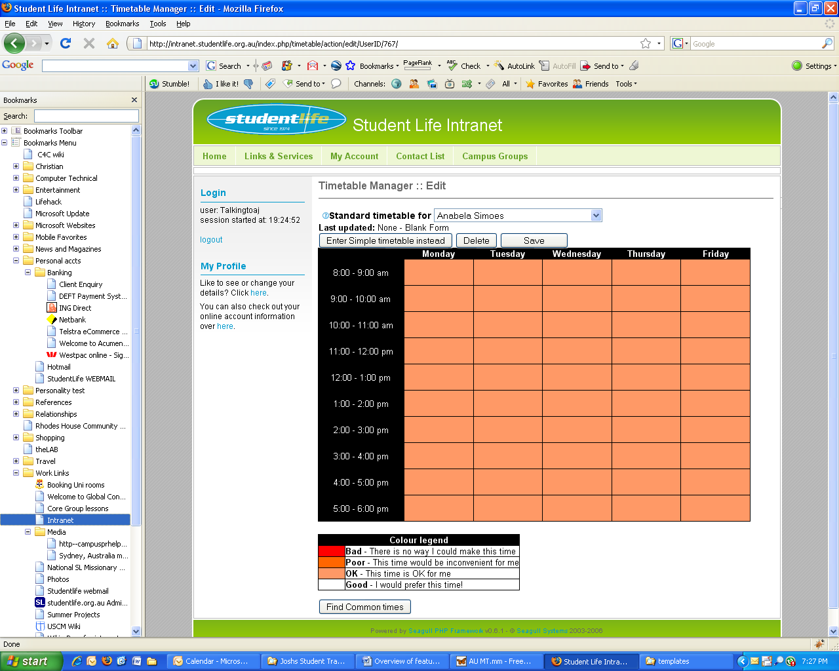
- Allows option of entering either Simple or Standard
- Allows delete or Save options for suitably authorised individuals
- On saving, if an alternative format timetable for this user exists, it is deleted.

View template
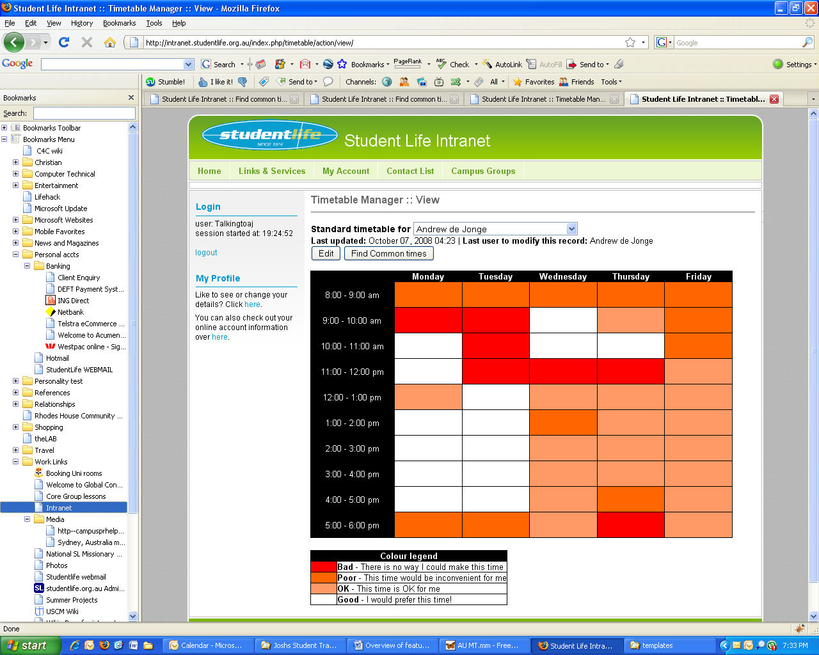

- Users are selected via a drop-down box. Perhaps replace this with a text box to type names with autocomplete feature either powered by AJAX or Javascript running off a pre-loaded user list.
- If user has both a STANDARD and SIMPLE timetable stored, shows the timetable last updated, but provides an option to view the other. (this shouldn’t happen though, as when one format is saved, the other is deleted)
- Provides option to find common times

Find common times template
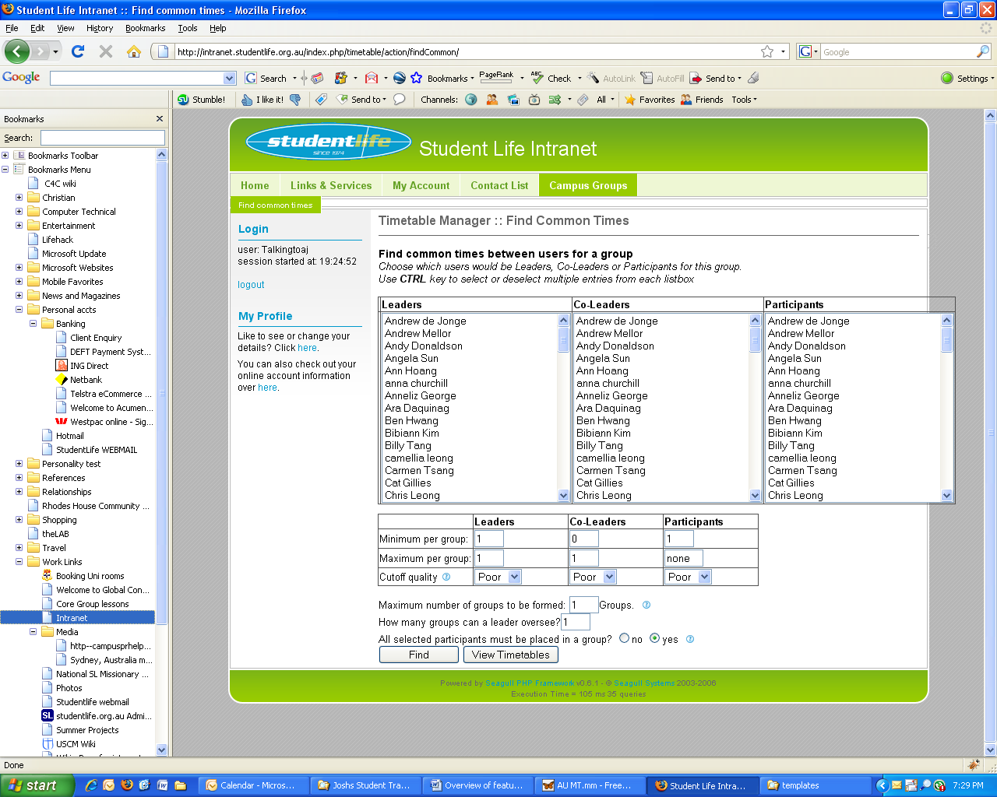
- To ensure users aren’t put into multiple categories, an autocomplete interface only lists users who have not been added to a category so far. This would prevent accidently selecting a user for multiple categories. “Leaders”, “Co-Leaders”, or “Participants” container.
- “Minimum per group” allows a search, for example, that requires at least 2 leaders per group, or to only form groups that have at least 3 participants in each. “Maximum per group” allows an upper limit.
- Remove the cutoff quality option... for all categories, if status is Poor or above, it is a reasonable time to consider, but user control of cutoff quality for searches in unnecessary.
- “Max groups to be formed”: More groups might accommodate more participant timetables.
- “How many groups can a leader oversee?”
- “All selected participants must be placed in a group?” : Solutions are much easier to find by “yes”. A “no” option involves creating an additional “not placed” group which must be considered when exploring all placement options.

Common Time Results template (single group)
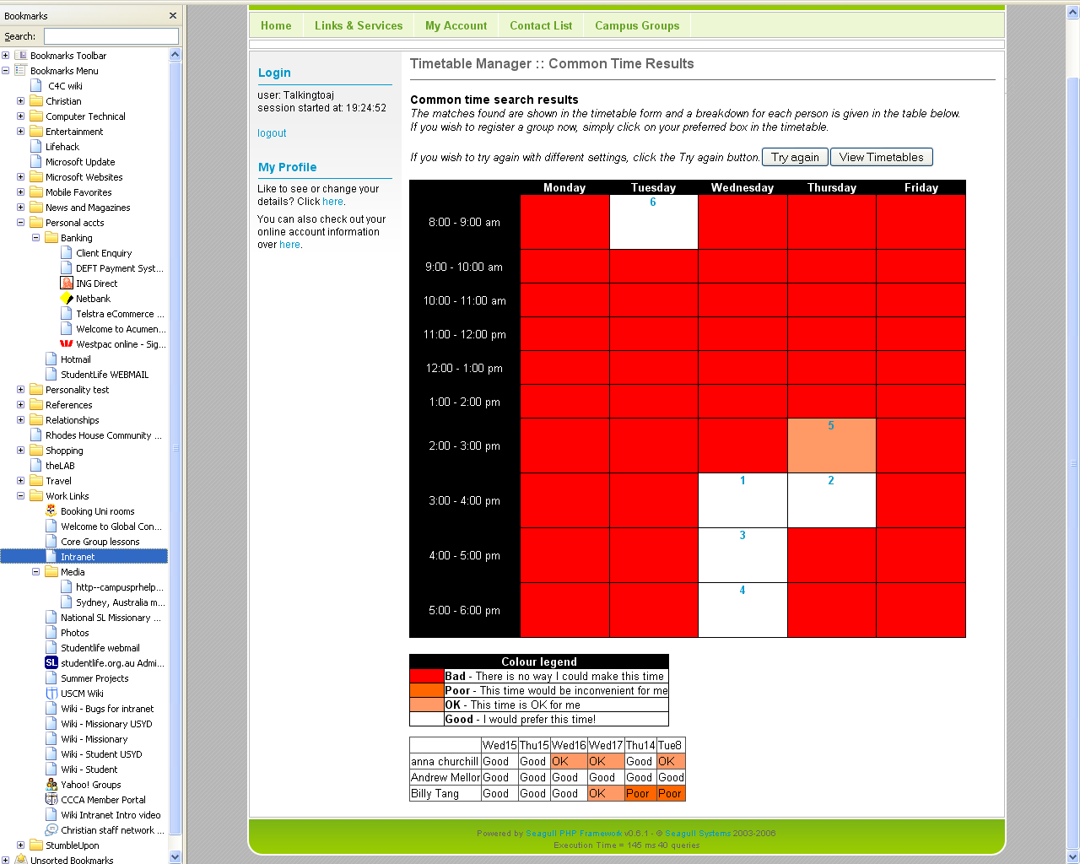
- When only one group solution is being considered. The solutions are displayed in a timetable with numbered priorities as per their suitability. The hyperlinks lead to group creation via the Groups module (see Group creation from timetable module)
- An analysis table down the bottom gives a breakdown of how the solution was found by showing individual results per user.
- We hope that solutions would take into consideration membership to existing groups (ie If “Billy Tang” is already a member of a group that meets at Wed15, it would take this into consideration. See Unsuitability for pre-existing groups)

Common Time Results template (multiple groups)
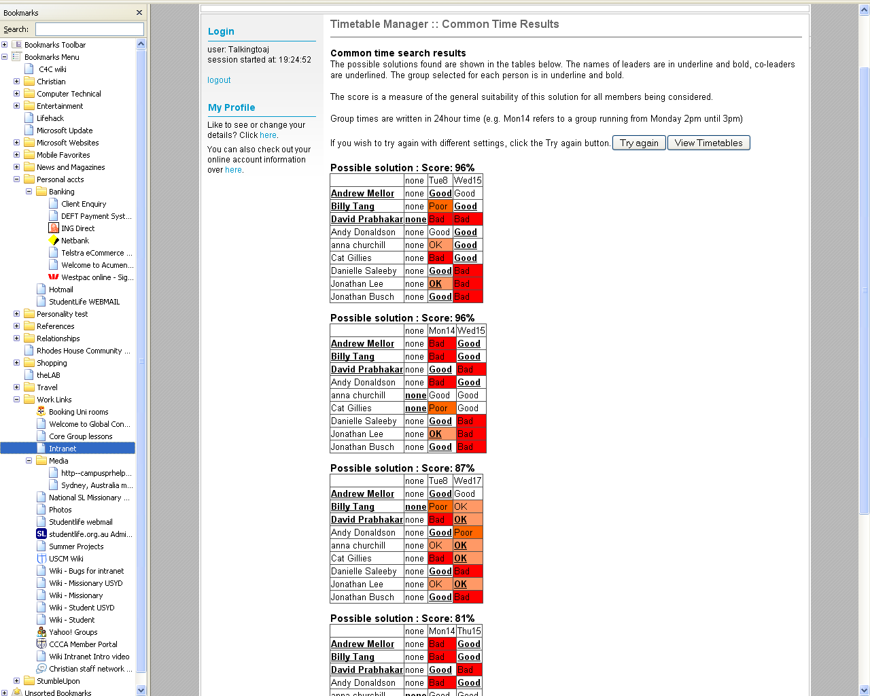
- We don’t attempt to display them in a timetable anymore!
- The label “none” refers to solutions we consider where we exclude one member from being assignable to any of the existing groups.
- Each solution set’s label (which currently just says “Possible solution”) could be a hyperlink which then opens multiple windows, one per group being created.

Compare times template

Compare times template (doesn’t exist yet):
- Staff have been asking for additional functionality from this module which allows a selection of times to be chosen, a selection of users, then just a comparison of their times to be displayed as in the example output below:
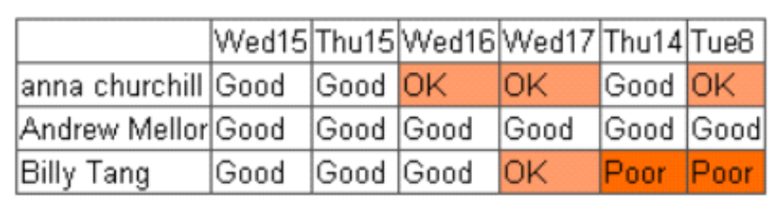

Group module
The group module tracks any weekly occurring events – from bible study groups, leadership meetings, discipleship times, evangelistic group meetings, to soccer on the oval.

Tracking these weekly events means:
- We can get an updated view of the user’s availability for other events (e.g. although their timetable says they are free at Monday 10am, a bible study group was scheduled to run at their time so in effect it is no longer free). See Unsuitability for pre-existing groups.
- We can produce a timetable-style view of all activities that are occurring on a campus which can be displayed on a public website to advertise activities.
- We can determine who is involved in the ministry, what activities they are involved in, and obtain some statistics for the ministry.

Member types
Users can be members of groups according to one of four types:
- Interested – a user who is expressing interest of being a part of this group
- Participant – someone who has already attended this group
- Co-Leader – an assistant leader who is learning how to be a leader
- Leader – the leader for the group (all groups must have one?)

Rundown on templates and module actions

Add template
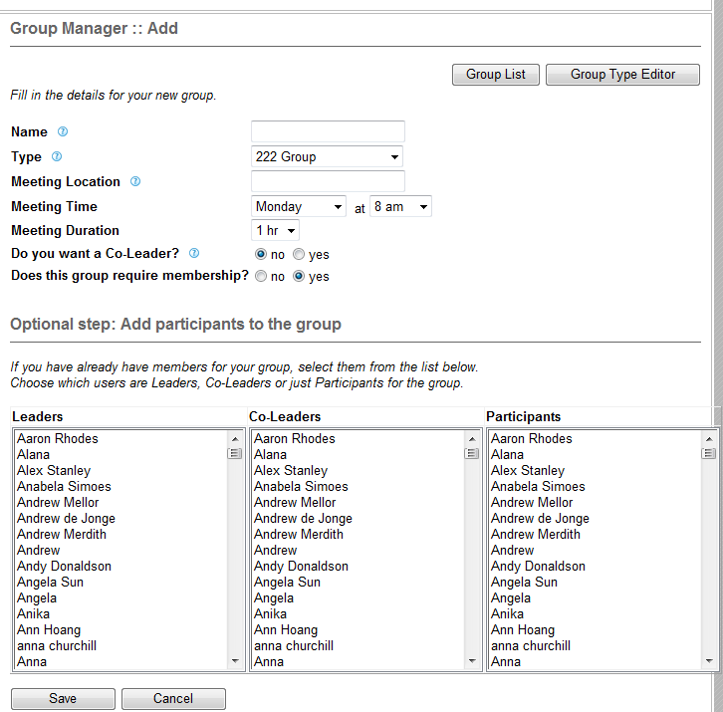
- Creates the group, and adds first participants
- We need an option on this page to be able to invite other users to be members. Only some users as leaders are able to add others (see mentor priority), but all leaders are able to invite other users.

Edit template
Edit group, change positions in group, remove members of group

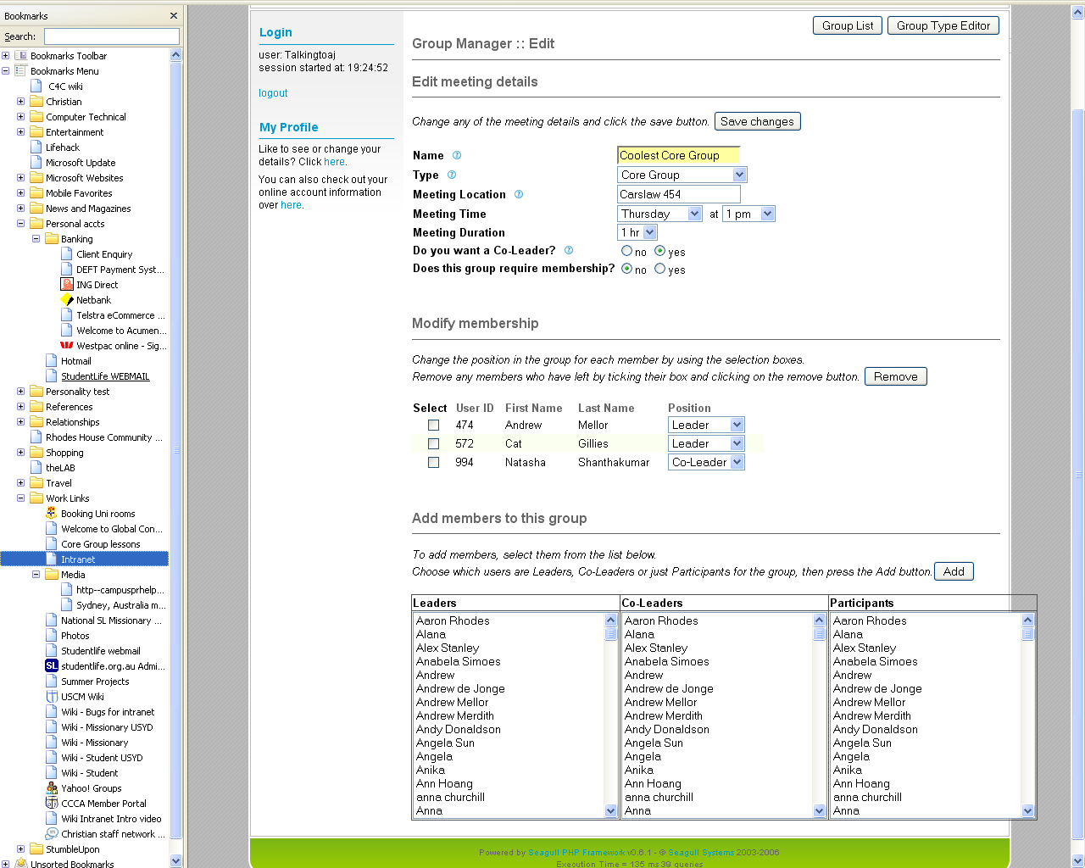
- “Do you want a co-leader?” enables the system to advertise a “position vacant” to other users who may be interested in applying as a co-leader.
- “Does this group require membership?” is not used. Delete it as an option.
- We need an option on this page to be able to invite other users to be members. Only some users as leaders are able to add others (see mentor priority), but all leaders are able to invite other users.

EDIT action=> GroupEdit.html => UPDATE action=> LIST action
UPDATEPOSITION action => GroupEdit.html
REMOVEPARTICIPANTS action => GroupEdit.html
ADDPARTICIPANTS action => GroupEdit.html

View template
Show group details and participants
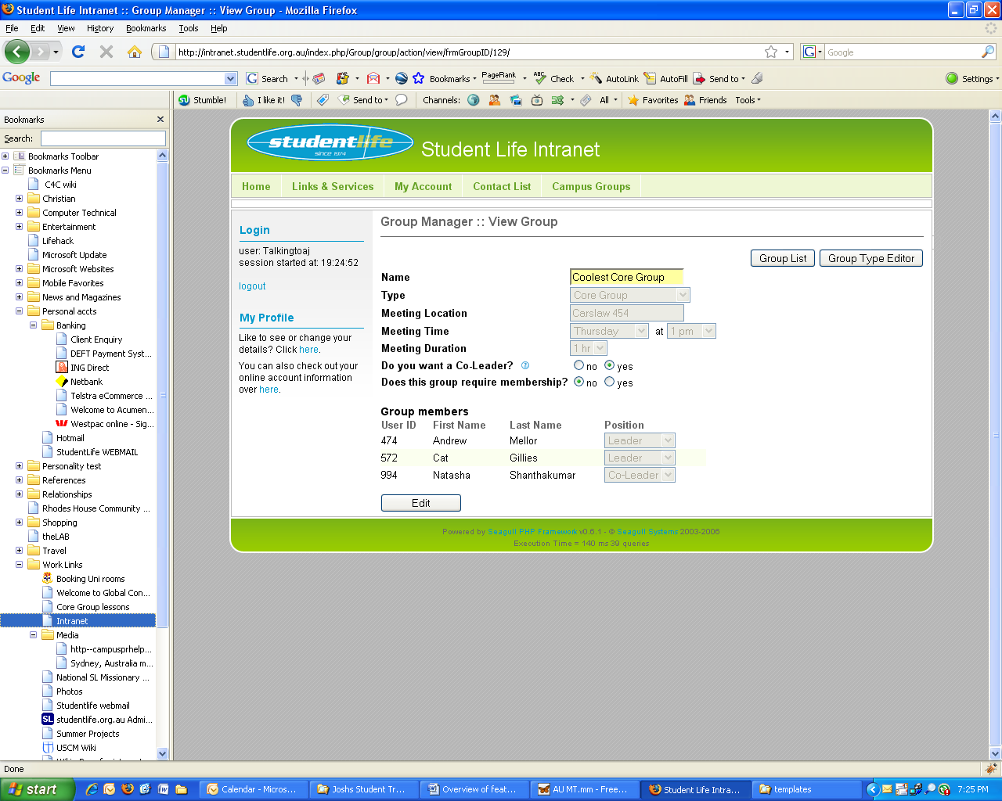

Quick-add template
groupQuickAttendeesAdd.html
(no picture currently available)

Used by the “WhoAttendedYourGroup” correspondence type, it allows the quick insertion of new attendees to a bible study group. This form exists to encourage bible study leaders to register new attendees to their group without having to go through a two step process of creating a user entry before being able to add them to their group.

Fields provided for entry:
- Firstname, lastname, mobile (optional), email, status/role (only list two possible roles in the dropdown - student, and student involved), position (ie interested, participant, co-leader, or leader)

Group Quick-add template
groupQuickAdd.html
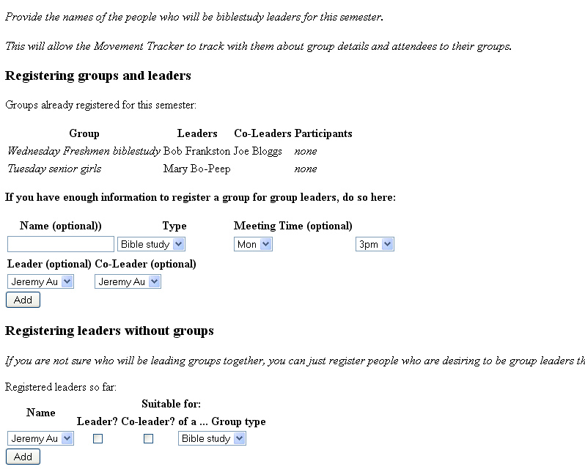
Used by the “AskForBibleStudyLeaders” correspondence type to collect names of the people who will be biblestudy leaders for an upcoming semester. This will allow the Movement Tracker to know who to track with them about group details and attendees to their groups.

Group type manager

Group type list template
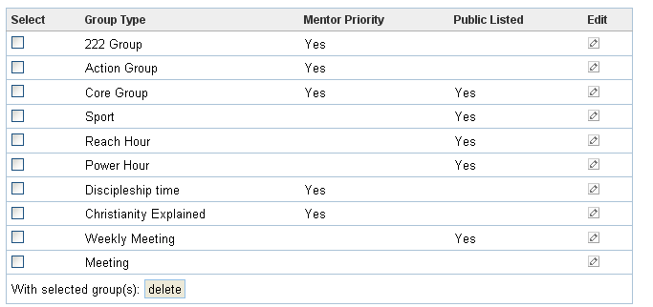
Lists:
- The group type name
- Whether this type has mentor priority
- Whether this kind of group should appear in the public listings of groups (ie displayed on a public website inviting anyone to attend without a prior invitation)
- We need an option asking “Do participants need to be invited to join this group?”

Group type edit template
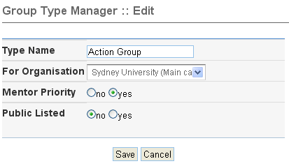
- Needs to include three more fields covering the Unsuitabiltiy for pre-existing group. One field each for leader, co-leader, and participant. Label it “How should this group impact a leader’s timetable?” with drop-down options of “OK, Poor, Bad” indicating how it will lower that user’s availability for that time, unless their timetable time is already of a lower status.

Unsuitability for pre-existing groups
When a user is a member of a group, it has a specific time which impacts one or more time slots. That membership should influence that member’s availability when the timetable module does availability checks. To achieve this, each group type should have an unsuitability index.

For example,
- A “discipleship time” group type might be set to “Poor” for “leaders” and “Participants” indicating that if that user was being asked to attend another group at that time, they would rather not go through the trouble of rescheduling their discipleship time.
- A “Bible study time” group type might be set to “Poor” for Participants and “Bad” for leaders, as there is no way a leader could be expected to give up their responsibility of leading a group at that time.
- A “sport” group type (e.g. weekly soccer on the oval) might have type “OK”, as skipping soccer for a higher good is acceptable.

Group creation from timetable module
After a search for common times, the timetable module allows groups to be created on the search results (see Common time results). It is a simple direction to the Group add template with the members and group time pre-loaded from the common time results. Where multiple groups are concerned, it popa up multiple group-add windows, each populated appropriately.

Mentor priority for groups
In determining the permissions for users (eg who can edit their profiles), being a leader or co-leader of a group in which another user is a participant is a considered factor. Not all group types, however, warrant this mentor priority for the leaders. For example, a 2nd year student may run a weekly soccer event where 4th year student leaders attend. It wouldn’t make sense for a 2nd year to be able to edit the profiles of all the attendees to soccer. However a bible study leader usually needs to be able to update the profiles of their bible study group’s participants.

Groups listed as “Mentor priority” can only be created by users with the status “Student Leader” and above.

Any leader can add other users as participants in a group they lead if it is not of a “Mentor priority” group type. Only “Student Leader” and above can add other users as participants to a “Mentor priority” group. Other users will need to manually invite them.

Campus Module

Our use of seagull organisations
We used to use organisations for tracking campuses. After meeting with Calvin, Russ, AJ and Dan, we decided this is not scalable because Seagull only allows a user to be a member of one organisation and there are scenarios where users are assigned to multiple campuses (see our new solution tracking campus assignment.

Tracking campus assignments

The problem
Some users oversee multiple campuses. Their permissions can vary for each campus. How can we give users access to the campuses they should be authorised to use, and track the appropriate permissions for each of these campus assignments?

DB model
We will adopt a method of tracking campus assignments by introducing an assignment DB table.
CREATE TABLE `assignment` ( `assignment_id` int(50) NOT NULL auto_increment, `user_id` int(50) NOT NULL default '0', `campus_id` int(50) NOT NULL default '0', `role_id` int(10) NOT NULL default '0', PRIMARY KEY (`assignment_id`), KEY (`user_id`), KEY (`campus_id`) );

This scheme is borrowed from the Canadian Intranet. This will enable us to scale for future integration with an anticipated global HRDB web service.

Implementation
We envision a dropdown navigation box that will allow the user to select their campus context. According to context, they will have access to MT functions in line with their role associated with that campus. Hence, a user could have involved student privileges on one campus but Student Leader privileges on another. Or a staff member on one campus could also be a campus coordinator on another campus.

A context selection dropdown will allow regional and national directors to examine individual campuses under their jurisdiction.

The user table will need to record the user's default campus assignment in a "campus" field. This is the starting context for when the user first logs in.

As the user changes campus contexts with the navigation box, the role_id and campus_id stored in the session variable will be modified.

Campus contacts
Campus contacts is a particular term used throughout the MT to identify who to forward user enquires to for the campus. Each campus has a male and female campus contact which is recorded in the DB. These male/female contacts allow the MT to know who to contact when a user without an RP requires action to be taken.

Campus contacts are often users with role “Campus coordinator”, but not always. And it is also possible that Campus coordinators can be different to male/female campus contact. This allows someone else on the missionary team to handle inquiries by new students.

Communications concerning the campus as a whole (e.g. “What are the semester dates for upcoming semesters?”) are not necessarily sent to the “campus contacts”, see campus communications for more information.

Note:
- Although a “Campus Coordinator” role exists, users of this role are not automatically considered “Campus contacts” by MT terminology, only those assigned to these fields in the campus DB table.
- Both the male and female campus leader may be of either gender. This can be necessary in a case for example where no female missionaries exist for a campus, in which case the one missionary may handle both male and female inquiries for the campus.
- Campuses may have none assigned to either the male or female campus contact role. This can occur when a new campus is beginning, or leaders have moved on leaving the post vacant.

Resolving vacancies
When no Campus contacts assigned for a campus and the MT is looking for one, a resolution workflow should be initiated by the MT (see Resolving vacancies of Top leaders)

Deleting groups, timetables etc
When a new semester begins, all user timetables from the previous semester are wiped. Archive all registered groups and group assignments from the previous semester.

Table
CREATE TABLE if not exists organisation (
`organisation_id` int(11) NOT NULL default '0',
`parent_id` int(11) NOT NULL default '0',
`root_id` int(11) NOT NULL default '0',
`left_id` int(11) NOT NULL default '0',
`right_id` int(11) NOT NULL default '0',
`order_id` int(11) NOT NULL default '0',
`level_id` int(11) NOT NULL default '0',
`role_id` int(11) NOT NULL default '0',
`organisation_type_id` int(11) NOT NULL default '0',
`name` varchar(128) default NULL,
`short_name` varchar(128) default NULL,
`description` text,
`addr_1` varchar(128) NOT NULL default '',
`addr_2` varchar(128) default NULL,
`addr_3` varchar(128) default NULL,
`city` varchar(32) NOT NULL default '',
`region` varchar(32) default NULL,
`country` char(2) default NULL,
`post_code` varchar(16) default NULL,
`telephone` varchar(32) default NULL,
`website` varchar(128) default NULL,
`email` varchar(128) default NULL,
`date_created` datetime default NULL,
`created_by` int(11) default NULL,
`last_updated` datetime default NULL,
`updated_by` int(11) default NULL,
`listable` int(1) unsigned default '0',
`FocusGroups` binary(1) NOT NULL default '0',
`MaleContact` int(11) default NULL,
`FemaleContact` int(11) default NULL,
`LastSemEnd` date default NULL,
`ThisSemStart` date default NULL,
`ThisSemEnd` date default NULL,
`NextSemStart` date default NULL,
`NextSemEnd` date default NULL,
`CurrentSemNum` enum('1','2','3') character set latin1 collate latin1_general_ci default NULL,
`ThisSemTimetables` date default NULL,
`NextSemTimetables` date default NULL,
`EmailForTimetables` binary(1) NOT NULL default '1',
`DeleteOldTimetables` binary(1) NOT NULL default '1',
`cutoffPeriod` int(11) NOT NULL default '2',
`student_num_name` varchar(128) NOT NULL default 'Union card number',
PRIMARY KEY (organisation_id)
) TYPE=MyISAM;

Templates

Campus manager edit template
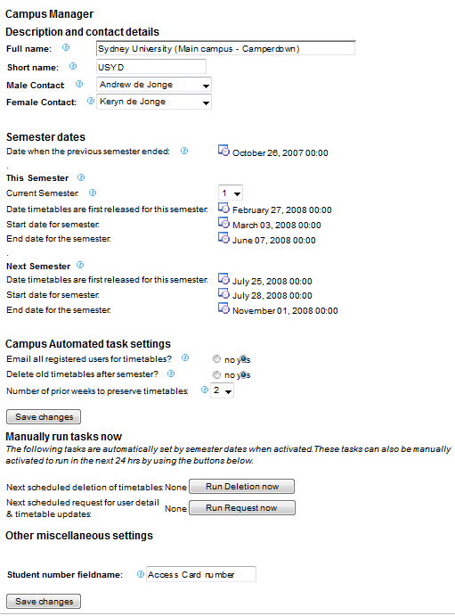

Campus manager list template
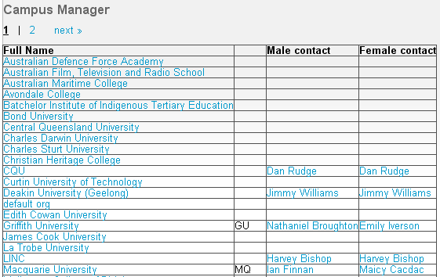
- Currently the list view only shows Campus contacts. It would be good to also list campus coordinators in another column.

Newsletter Module
Allows mass-mailouts to Lists (as per List module). Lists function a bit like facebook groups.
It would be great to have a unique email address generated for each list.

Newsletter create template
A mass-mailout can be sent to a list either by:
- An online WYSIWYG editor box
- Emailing the unique email address
- Uploading an html document?

Permission to email lists, is controlled by the list module.
Replies to a mass-mailout are handled according the the list’s guidelines.

Newsletter List template
It may be good to eventually have a record of conversations associated with any particular list.

List module
Handles the management of lists – collections of users which can be a dynamic list (thanks to SQL queries, or according to Roles, e.g. “everyone who is a male and in 1st year”), or static list (eg “users with userid 241, 4212, 1432, 223”), or a combination of the two.

Lists provide a means of emailing or detailing a list of a particular category of people which is guaranteed to be up-to-date.

Creating a list
Any user can create a list of users which they can view.

Field: Name
A short name for displaying the list
e.g. “Winter conference planning team”

Field: Description
A description of the list’s contents.
e.g. “Join this group if you’d like to be part of the Winter conference planning team”

Field: Publish scope
A list by default is private (unpublished), and only appears for the creator user.
When a list is published, you can select whether you wish to:
- Publish it campus-wide
- Publish to a certain role and above on their campus (e.g. “Only display for users from my campus of role Student Leader and above”)
- Publish to all campuses for the role “Missionary”/”Ministry leader” and above

Field: Edit/Delete permission
You also select the edit and delete permissions by selecting a “role and above” setting (e.g. “only missionaries and above can edit my list”). Perhaps edit and delete permissions are identical.

Field: Join permission
You also select the join permissions by specifying another list. (e.g. “My “Only display for users from my campus of role Student Leader and above” list describes the group I will allow permissions to join my new list). This allows lists to function in a similar manner to facebook groups – e.g. “Join this group if you’d like to be part of the Winter conference planning team”)

Field: Email permission
Email all/Email owner option: Can any member use the list to email all members of the list? Only Student Leaders can change this option from the default of “Email owner”. Lists set to “Email owner” mean that replying to an email sent by the group will be sent to the originator of the message.

Fields: Members
Lists are populated in a two-stage process:
  - By search query
The search query option allows you to maintain a dynamic list. For example, “everyone who is a male and in 1st year” will keep itself continually updated. The search query stage should allow the inclusion of pre-existing lists.
e.g. Albert, Bob and Charlie all create individual lists of all their male disciples who would be suitable to ask to leadership roles for next year. Derek then creates a list that inherits from their three lists to produce a master list that can serve as an invitation list to the leadership challenge night

  - By individual selection/de-selection
A window lists the records resulting from the search query. Now the user has an opportunity to deselect certain contacts or include others.
User case: “I’m wanting to choose users who would be suitable to invite to our men’s retreat. I search for all males from my campus, but I then de-select Frank because I know he’s overseas at the moment.”

To avoid circular referencing problems, you could internally have two arrays. One for list_ids, and one for user_ids. As it recurses down thru the search queries of lists, if that list_id already exists in the list_id array, it doesn’t recurse down again.

Search query building
It is very important to make sure query building is non-technical and accessible by the average user.
Lists can always inherit from other lists to allow power-users to compiles lists of a complexity not provided by the web form.

Field: Dynamic?
When the list is saved, the user has the option via a checkbox to “save static” (the default is dynamic). This will mean that it populates the list now, but then only saves a list of individual user_ids. No inheritance from search queries. This would allow a user to compile a list once and not fear his list being altered by campus movements.

Actually, we don’t need a “Dynamic?” field, simply save the list as a series of user_ids and no list_ids.

Field: Official
Is this an official list? [Yes/No]
If it is official and viewable by anyone, this list will be shown on the public website (e.g. a list of people to contact if you would like to join our club)

Field: Expiry date
Automatically delete the list at a particular time
Options:
- at the end of the Semester
- at the end of the Uni year (default?)
- never

Permissions
Create permissions: Any user can create a list.
Publish permissions:
- Publish it campus-wide – Available to users of status student leader
- Publish to a certain role and above on their campus above – Available to users of status student leader
- Publish to all campuses for the role “Missionary”/”Ministry leader” and above – Available to “Missionary”/”Ministry leader” and above
Email-all permissions:
- Unless set to “Email all”, Campus-only lists can only be email-alled by Student leader and above
- Unless set to “Email all”, All campus lists can only be email-alled by “Missionary”/”Ministry leader” and above
View permissions:
- All users can view lists according to their published guidelines
Edit permissions:
- As per the list’s guidelines
Delete permissions:
- As per the list’s guidelines
Join permission:
- As per the list’s guidelines

Region manager
Handles a heirachy of campuses into regions, and introducing roles that allow a user to hold a regional title. Allows users to be assigned to multiple campuses. Introduces regional “containers” as a group which a missionary can be assigned to (eg a missionary could be assigned to a state regional role without necessarily belonging to a campus.)

Campus contact
Campus contact is the head contact person for a region (or campus). In the case of a campus, the campus contact is the campus contact of the same gender of the user (or both the male and female campus leaders listed, depending on context).

Resolving Campus contact vacancies
(see also resolving RP vacancies for a similar topic)

When no campus contact is assigned to a region/campus and the MT is looking for one, the following resolution workflows should be in place:

1. Find a contact to handle the immediate action
- Search the campus for any users who are assigned to the role of “Campus Coordinator” or “Regional director”
- If unsuccessful, search for any user who is assigned to the role “Ministry Leader”
- If unsuccessful, start moving up the chain to the region overseeing this campus and ask for its campus contact. If that fails, this function call should do its own iterative search of higher regions.

2. Request for the post to be filled

Pre-emptive workflows to help minimise vacant posts
All campuses and regions should be part of one heirachy tree. Ensure that the top region always has someone in the post.

Backboneauth module
We need some mechanism to allow the Movement tracker to communicate desired authorisation settings to other CAS-enabled web-services. (e.g. “Please let this student access the wiki, but with view-only privileges)

The Backboneauth module provides functionality to allow:
a) External authentication to provide Single Sign On with the Movement Tracker being the central authentication hub
b) Allow authorised external hosted web applications to share data across different systems (ie. share personal details)

These requirements was initiated to allow a wiki to be integrated in some way to the Movement Tracker, to allow a user to log in once and access both the Movement Tracker and Wiki seamlessly. The added requirements was the sharing of user data and permissions be mapped between the two applications (ie. a Sys admin on the Movement Tracker is the Sysop on the wiki).

The implementation was custom designed, and does not confirm to current SOAP or REST specifications. It provides a secure communications over HTTP through a plain text, MD5 hashed shared key for message authentication. This amount of security is enough for providing transmission of non-authenticating text.

Scenario 1: Intranet and Wiki
The Wiki will continue to have its own user base for internal use, but the wiki will be authenticated externally. In our case, the Intranet will most likely become the "authentication provider".
- When a (Wiki)page is requested by a user, MediaWiki will need to check whether a Session has been established with the user.
- If so, then all is normal.
- If not, MediaWiki shall redirect the user to the Intranet, sending meta-information in the same request. If the user is not already logged in, the Intranet will display the login page etc.
- If the user has already logged in the Intranet, the intranet will once again redirect them back to the Wiki, along with a encoded "token" for the user's web browser to send back to MediaWiki.
- MediaWiki will validate the token to be geniune, if everything is good, the user will be logged in MediaWiki, as long as the user already exists in the user base.
- If the user is not already in the Wiki's userbase, the Wiki will create a new record in its userbase, populating the required data fields (username, firstname, lastname, possibly group/role?) that it received along with the token.

Message structure
A shared key is used to verify messages, but the shared key is never sent out in plaintext. A token is generated in a format identical to: [version/time/service/data]. The shared key is appended to the end of the token and a hash is created using MD5 algorithm.
Messages basically consists of the non-encrypted token and the hash, where the destination can then generate a hash from the message to compare with the received hash. This allows integrity of the data (As the data is hashed) and the integrity of the source (Source must have the shared key).

Module classes
There are two main classes in the current module implementation:
- BackboneMgr – Handles authentication to external web services
- HostInterfaceMgr – Handles data requests (ie. User details) from external web services

BackboneAuthMgr
Currently all external services are hardcoded and not handled by a database. Future develop will hopefully see this be refactored and external web services and mapping information will be stored on the DB.

This generates the required tokens and outputs a html form to the user. This form is configured to POSTing data when the page is fully loaded. In the case of the wiki service, it will send the form data to the Wiki, the data will contain the token. At the Wiki end, a plugin has been created and installed to handle these custom requests.

HostInterfaceMgr
The opposite to BackboneAuthMgr, where it will accept HTTP requests that are requesting data. It will break apart the token to the individal parameters, and check the hash. The token should include a parameter on which service is requesting information, and will use the key assigned to the specific web service to make the checks.

Upon success, a plain text return message with a conforming HTTP/1.1 header is generated. It will pass back the requested data, or send an 'INVALID' text if it failed in any circumstances.

User module
Handles account creation, registration and authentication.

Registration
There are two ways a user account can be created. Firstly a user with role “Student Leader” or above can create a new user entry in the MT. Secondly, anyone can visit the MT website and apply for an account by claiming to be a student currently involved in the local ministry.

Registration method 1: Leader creates account

Why?
The leader may be a small group leader for which the student in question has begun attending their small group. Of course, there are many other scenarios when this could also occur – it could be a student who has attended the main meeting where a roll was taken.

How?
A button allows the creation of new users. Many personal detail fields are presented for entry. Student detail entries should also be allowed for immediate entry on different pages accessible via tabbed browsing (javascript tabbed browsing that doesn’t require re-loading).

Workflow:
The following section is the workflow that initates when the leader creates a new user.
- Leader will select the 'Add user' button located on the Directory Listing page.
- MT will produce an empty “General Details” form.
- Leader will complete as many fields as they wish (only the Email and FirstName fields a required), one field presented will be to allow the leader to specify who the new user’s RP will be, otherwise it defaults to the leader creating the record. The leader is not able to set the user’s “username” field. The “Role” field is by default set on “Student” unless changed by the leader.
- MT will create a new user
  - Their role is set to “Registration Incomplete” with the Role selected by the leader stored in a RolePending field for now.
    - Set verified_by field to user id of the current user creating the new record
    - Check the selected role id that it is within specs (users can set records to roles only of levels lower than themselves (eg Student leaders can set records with a role of Student or Student Involved, while Missionaries can configure new records with roles of Student Leaders etc.)
    - If the new record belongs to a student, insert an empty student row in the DB
    - Insert empty timetable rows
    - Log the creation of the new user via the Log module
    - Send email to new user with an invite and a request to complete their registration via the Correspondence Module, correspondence type “LeaderCreatedYouAcctPlsVerify”
  - Return leader to the newly created profile in view mode.

The following workflow begins when the user receives and responds to the “LeaderCreatedYouAcctPlsVerify” email.
- MT will validate the request (Note that at this stage the user cannot log in, so the correspondence module is able to take them through a different process for non-logged in users where they are identified by the unique key that was embedded in their verification email link.
- MT will display a form for the user to complete their personal details and their login details (password, username).
- User to agree to Privacy Terms&Conditions (a legal requirement in Australia)
- MT will again validate the user (Remember the user is still not logged in, so check for spoofs).
- MT will update the user details on the database, update the timestamp of last change. Activate the account and empty the verified_by field. The user’s role is now updated to that stored in the RolePending field. (eg from “Registration incomplete” to “Student”)
- Optional steps presented to user: User to submit their timetable, and choose any public list they would like to be involved with.
- MT will check the submitted form is not spoofed (matching form user_id with the one in session). MT will do a timetable update with the data.
- MT will redirect user to home with a message notification of success, and automatically log them in.

Registration method 2: User creates their own account

Why?
There are several ways this could occur:
- A student on a campus hears of the MT and visits the website themselves to gain access.
- Students involved in a campus are sent an email with a link to a website that can only be accessed with a MT account. The student is redirected to the login screen and clicks on the “not registered yet” link
- A web surfer discovers the CCC ministry on the web, locates the MT login screen and applies for an account (then choosing “I don’t know any leader” option from the “which leader do you know best?” question during the login process.

How?
- Attempting to access secure pages or websites will redirect the user to the login page of the MT where a “Not registered yet” option exists.
- Otherwise, going to the MT website will present the login screen which provides the “Not registered yet” option.

Current Workflow:
The following workflow begins when a user clicks on the “not registered yet” link.
- The user is asked for their personal details (including preferred username and “leader who knows you best” = RP )
  - If no RP was chosen (ie “I don’t know any leaders”), the user’s RP field is set to null.
- User to agree to Privacy Terms&Conditions (a legal requirement in Australia)
- A verification email is sent to their provided email address containing their username, a randomly generated password and a link back to MT.
- A “PleaseVerify” email is sent to the RP providing instructions on how to personally verify that person. Email shall contain a direct link to the verification page with the newly registered user's id embedded in the link to allow the RP to allow/deny the user.
  - If no RP was selected by the user then a “PleaseVerifyUnconnected” email is sent the campus contact instead.
- At this stage, the user’s status is set to “Approval Pending” giving them only minimal access to the movment tracker until their RP can designate a more appropriate level

The following workflow begins when the user responds to the verification email sent to their provided email address:
- User follows the verification link sent by email
- User picks a password
- Optional steps presented to user: User to submit their timetable, and choose any public list they would like to be involved with.
- The user is directed to their home page. If the user is still of status “Approval Pending”, provide a status message to the user to the effect of “You have only limited access to the Movement tracker for now as we are still waiting for <name of leader they chose> to verify your identity.”

When the leader responds to the “PleaseVerify” email:
- Leader follows the link in the email received which will take the leader to the MT.
- MT checks if the user has already logged in, if not then present the login page. Once leader has logged on, redirect user to the verification page (Correspondence module handles the redirection and also updates that the leader has followed the link)
- MT will bring up the new user’s form with instructions on how to determine whether this user is who they claim to be (email addresses must match that known, if the leader does not know the email address of the student, they are asked to phone the number provided and to verbally identify them over the phone. This is to avoid spoofing)
- Leader can now complete/correct fields of the user and choose a suitable role for the user.
- The Leader selects either the Accept or Reject button.

Accept workflow
- MT will update the database entry for the registrant with any updated information from the form. MT will assign the leader's user id to the verified_by field of the registrant's record on the DB.
- MT will change the user’s role from 'Approval Pending' to the newly selected role.
- The new user will be informed of the acceptance via “HasBeenVerified” correspondence.

Reject workflow
- The new user will be informed of the rejection via “Approval Rejected” correspondence.
- MT will delete the account entirely.

New workflow:
Currently the MT rejects them if they specify an email address that already exists in the MT. This has caused many problems (e.g. a leader created an account for them, they didn’t get the email as it went to their junk mail folder, a month later they try creating their own account and are rejected as the email address is already registered). Hence, to allow a merge of the new account creation with the current account, we will amend the workflow to the following...

The following workflow begins when a user clicks on the “not registered yet” link.
- The user is asked for login details only (preferred username, email address and password)
- A verification email is sent to their provided email address containing their username, a randomly generated password and a link back to MT.

The following workflow begins when the user responds to the verification email sent to their provided email address:
- The user is asked for their personal details (including preferred username and “leader who knows you best” = RP )
  - If no RP was chosen (ie “I don’t know any leaders”), the user’s RP field is set to null.
- User to agree to Privacy Terms&Conditions (a legal requirement in Australia)
- A “PleaseVerify” email is sent to the RP providing instructions on how to personally verify that person. Email shall contain a direct link to the verification page with the newly registered user's id embedded in the link to allow the RP to allow/deny the user.
  - If no RP was selected by the user then a “PleaseVerifyUnconnected” email is sent the campus contact instead.
- At this stage, the user’s status is set to “Approval Pending” giving them only minimal access to the movment tracker until their RP can designate a more appropriate level
- Optional steps presented to user: User to submit their timetable, and choose any public list they would like to be involved with.
- The user is directed to their home page. If the user is still of status “Approval Pending”, provide a status message to the user to the effect of “You have only limited access to the Movement tracker for now as we are still waiting for <name of leader they chose> to verify your identity.”

If you’re adding a person who exists on another campus, prompt the user to confirm before adding them to this campus as well.

Forgot password procedure
If a user has forgotten their password, this link on the login screen allows them to enter an email address.

- The web page confirms if the email address is registered or not to the user, then telling them to check their email account.
- A random password is then generated for them and sent to their registered email address.
- The user is now able to log in using either their original password or the newly random generated password.

Login process
Users have two password fields, “Password” and “RandomPassword” (used when a password is forgotten, or a new account has been created).

Whenever a user logs in, the MT checks if the user’s “RandomPassword” field is set to null.
If not,
If the user logged in using their regular “Password”, “RandomPassword” is set to null now and login is completed.
Otherwise,
the user is directed to a screen to reset their regular “Password”. On completion, the “RandomPassword” is set to null now and login is completed.

This process allows users to remember their forgotten password, or removes the inconvenience of a malicious user continually claiming to be someone else who has forgotten their password resulting in annoying resets of their regular password.

Email change workflow
Email address changes need to be handled carefully as they provide a primary way of authenticating the actual identity of a user.

Email change notifications
Notifications consist of an email to both the old and new email address informing them of the change, who made it, and an email address to contact if they believe there has been a problem with the change.

Changing someone else’s email address
Only users of a higher role can make changes to another user’s account, and only if they are at least “Student Leader” role (eg a “missionary” can change a “student” account’s email address). In these cases, no email change verification takes place – only a notification is sent out.

Removal of users
Users can be removed from a region two ways:
- By archiving (see Archiving users)
- By changing their assignment to another campus

Archiving users
When a user is archived, a reason must be given:
- Not involved (ie “this student has not been involved in the ministry for a while and can no longer be considered a part”)
- Graduated
- Other

The checks that need to be performed before a user is archived:
- Who are they an RP for? (reassign all dependents a new RP)
- Are they a campus contact anywhere? (notify campus leaders asking for a new assignment to this post)
- Are they a leader for any groups? (reassign to their RP)
- Are they the owner of any lists? (reassign to their RP)
See resolutions of the vacancies for more details.

It could be a useful feature to produce a confirmation page notifying the user of the changes that will be made and providing a chance to reassign to a different person for each case.

The account should be disabled. Remove all their membership from all groups.

There should be a mechanism to display archived users, and potentially “resurrect” them.

Records module
The records module handles the directory listing of user information

Directory listing
The directory just lists contacts for the user’s current campus context (see multiple campus assignments)

The directory listing is paged and sortable. Shows basic details:
- Last name, First name, Home phone, Mobile phone, Email address
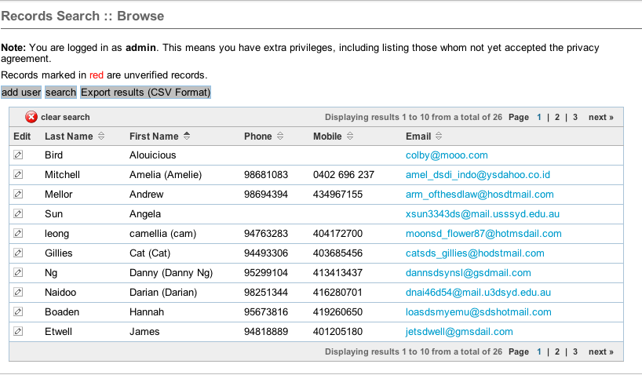

Users who are of role “Registration Incomplete” or “Approval Pending” or “Honourary Member” are not included in a campus list unless the user is of level “Ministry Leader” or above in which case the entries are colour-coded differently (red for “Registration Incomplete” or “Approval Pending”, green for “Honourary member”)

Each row has an Edit column. A hyperlinked icon shows up on this column besides each person whom the current user has access to a detailed profile. Everyone has access to their own profile so this icon should show next to their own row. For student leaders and above are able to access all users with lower roles.

The Edit icon will appear for people whom the current user has access to. This is checked by an external process from the Group module through the function GroupMgr::getChildren($usr_id) which when passed a user id (in this case the current user) will return a list of users (currently by returning an array) that can be edited by the specified user.

A button enables the current view to be exported directly to CSV. CSV results contain all data that would be viewable to the user. (ie, for the users they are allowed to view/edit, it provides the data that would be displayed on the tabbed pages.)

Student leaders and above are able to create new users on the system.

The directory list can be filtered through the use of the search facility. The search function can also display records from other campuses. The results appear in the same template as the directory listing, with the exception of a 'clear search' button to return the listing to the default state.

Search template
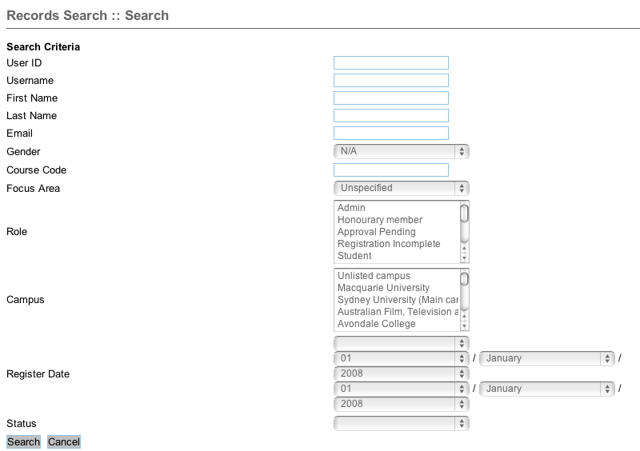
The results are displayed in a similar manner to the directory listings.

The results page provides an option to create a list from the search results.

User’s profile view and edit
The profile of each person begins with the general tab screen. Information is organised into tabs, “Profile”, “Training”, Event history”, “Group Involvement” and “Timetable”. In the viewing mode, the information for each tab is loaded at the same time, so changing tab views will instantly display related information thanks to Javascript. What was on the Student tab in the new version appears on the Profile tab.

Profile tab:
Generic contact details.
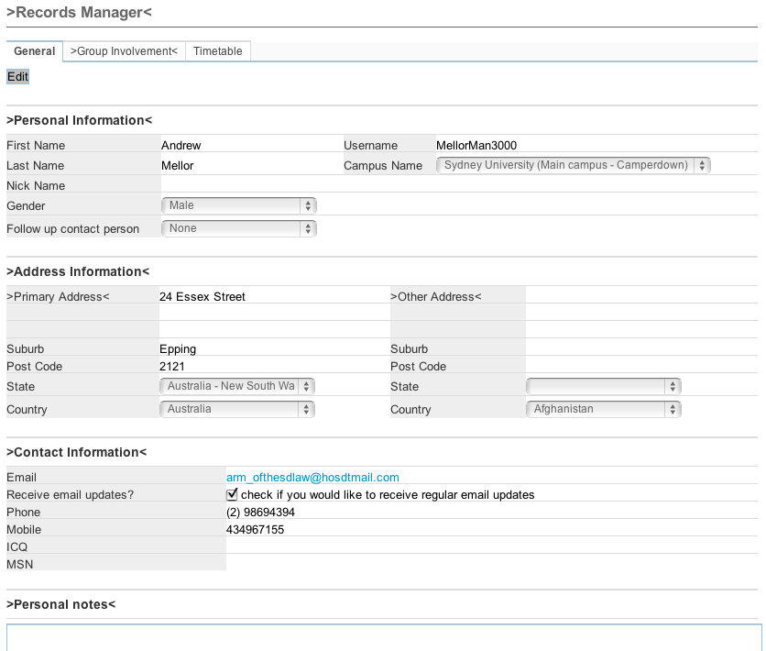

A button allowing the viewed user to be archived. A reason is then asked for archiving, options being “No longer involved, graduated, other”.

Display the last person that made updates to the record, and when that event occurred.

Email notifications should be sent to a user and their RP whenever fields to a user’s profile are changed, listing in the notification what changes were made (old value and new value) and who made them.

Changing username of a user
There is a username field and contact email field.
If the email address was changed, the user will be sent an email to complete a email address notification.
If a username change is attempted, since it is the GCX login username, we’ll just kick the user over to GCX to complete the desired action.

Unregistered profiles
In the case of the user being 'unRegistered' buttons will be displayed to allow the viewer to either “Re-issue an invite” (ie when we created an account on behalf of a user but they haven’t responded yet) or “Verify the user” (ie the user initiated their account but a leader hasn’t yet verified them as genuine)

Contact detail fields that may change
Currently MSN and ICQ fields are provided, but these fields may vary according to country and over time. We also have a number of variable fields that can be set on a campus level?

Each field has a “leadership only?” flag to specify whether the data field can be seen/modified by the student or just other users able to edit that record.

Creating a new record
At the minimum, an email address and a first name must be provided for a record to be created or edited. If the viewer is the owner of the record, then there are additional compulsory fields:
- Lastname
- Gender

See Creating a new user record for more information related to the workflow that ensues.

Including Student information
The AU MT had a seperate Student tab. We need to include that information now within the profile tab.
- Details relating to the user’s Uni course. These fields will provide a lot of management power to Campus Directors. For example, being able to tell what students are graduating in the next 12 months helps with planning who should be trained up to ensure there will be small group leaders available in the coming year. Reports provide useful processing and compilation for this information.

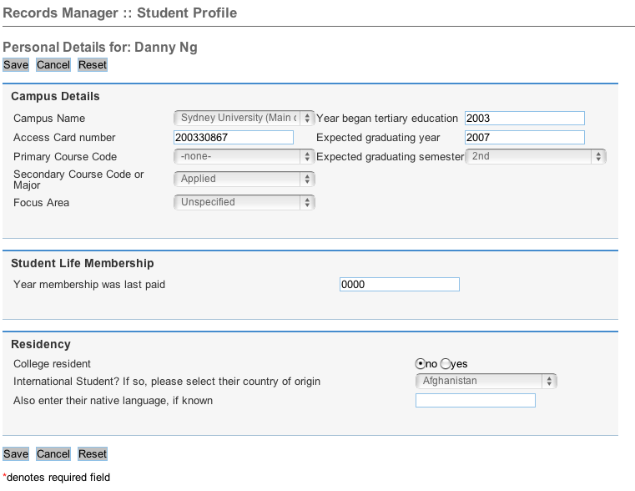

Course codes
Each installation has their own list of standard course names. When a user selects their course from a drop-down, if their course doesn’t exist, they can choose “other” which displays a text field for them to put in their own course name. That new course name is added to the database listing, but marked “to review”. A notification is sent to a national admin of the addition who is then charged to review the addition and either confirm, or delete. The deletion action will ask the admin for an existing course code to re-assign all users currently using that course code.

Training tab
What training has been completed can be selected by anyone, but the approver’s name is listed next to that training along with the date.
The clear button will clear the date and approver.

Both these buttons are available to the student themselves. They may approve themselves for training they believe they completed, or remove completed training they desire to repeat themselves.

Event history tab
???

Group Involvement tab
Group summary information

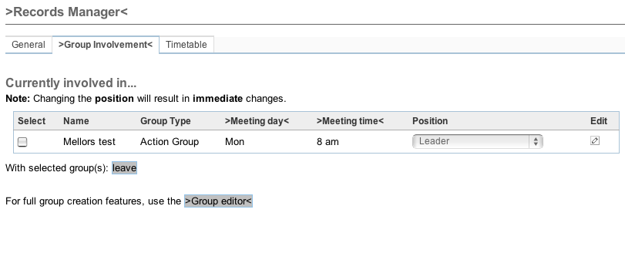
The Group Involvement page shows all the groups that the user is currently involved in. It includes a summary about the type of group, when it meets and what rank the person is at within this group. From this page, you can drop involvement with a group or change the person's position (rank) within the group. There is a hyperlink to view a greater detail of the group, and another link to take the user to the group editor.

Unless the user is a leader, all options are disabled (or do not appear on page).

Timetable tab:
It shows the availability of their time during a Monday-Friday week. It will also show group meetings in the specific slots as text hyperlinks that link to the group manager for further detail.

Reports

Graduation report
The user selects a time period (next 1, 2, 3, or 4 semesters), then the report produces a report with the following fields:
- Name
- Role
- Anticipated semester for graduation
- RP

Although this report and many others technically are already available by using the “Search” function in the records module, their availability would not be obvious to the majority of users, so providing Reports will increase the number of MT users who can use the MT’s features to full advantage.

Discipleship tree report
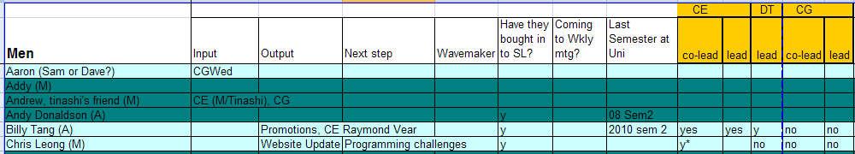
Staff always want a discipleship tree which shows who disciples who. The user would select either a user or a List. All dependents under that user or list will appear in the report (e.g. “show me Bob’s discipleship tree” or “Show me the whole discipleship tree for Penn State campus”)

A discipleship tree can be very efficiently represented in a flat table report by using the following fields. It is not as visually pleasing as a visual mind-map, but arguably more useful in planning:

Fields to include:
- Name with the name of their RP in brackets after their name
- Input: This field contains the name of the types of groups that this user is a member of, groups where they are participants rather than leaders (e.g. “bible study group”, “Weekly meeting”)
- Output: Names of the types of groups that this user is a member as a contributer. (e.g. “Bible study group leader”, “Advertising team member”).
  - It would be good to have some means in the MT to track responsibilities users may hold. This information could then be displayed here as well (e.g. “Treasurer”)

A visual mind-map version of a discipleship tree:
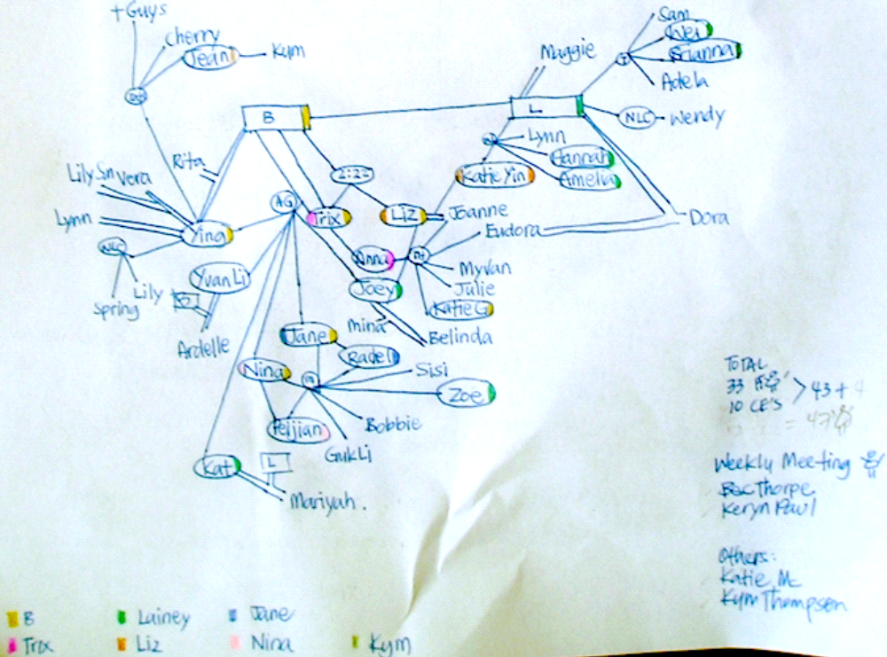
The classical discipleship tree is drawn by hand as a kind of mind-map, however these can be quite messy and difficult to decide how to draw. The more information you try to visually present as linking lines, the tricker these can become. I suggest this be one of the last types we try to code, as a cool side-project rather than considering it a key part to the project.

Types of information that might need to be represented in a visual mind-map:
- Student names
- Their role
- RP relationships
- Whose small group they are a member in
- Whether they are Christian or not

Libraries & Other

Emailer
The Emailer library file (lib\MT directory) centralises all email processing. Emails are sent in MIME format with a text body and html body to allow for email readers that do not read html. Hence, all correspondence types have an html template and text template associated with them.

Permissions and Roles
ROLES
// 11: Admin
// 10: Campus Coordinator (The missionary(s) who oversees the ministry on a given campus. Suitable for both CD and ACD)
// 9: Ministry Leader (a student who oversees a campus in a capacity similar to a campus coordinator, eg Catalytic campus leader)
// 8: Missionary (A Missionary on a campus where there is also a Campus Coordinator)
// 7: Student Leader (A senior students in the ministry with authority to oversee other students)
// 6: Involved Student (A student who is involved and committed (they should have been attending Student Life for at least 6 months to qualify)
// 5: Student (A student who is an attendee of Student Life at a campus. Default status for all new student accounts)
// 4: Registration Incomplete (A leader has registered them, but user has not completed rego and signed the privacy policy)
// 3: Approval Pending (They have applied, but a leader has not verified their application yet)
// 2: Honourary Member (not a valid student or missionary, but we are giving them limited access anyway. Possibly an alumni who keeps in contact)

Permission groupings according to Role
$Priv = array(
'allRoles' => '2,3,4,5,6,7,8,9,10,11',
'registeredRoles' => '11,2,5,6,7,8,9,10',
'unRegistered' => '3,4',
'notViewable' => '2,3,4', // These roles are generally not viewable
'notCampus' => '2,3', // These roles are not campus
'isCampus' => '11,4,5,6,7,8,9,10',
'isAdmin' => '11,8,9,10', // Missionary roles and LINC leader role
'isLeader' => '11,7,8,9,10', // student leader and above
'isStudent' => '5,6,7,9', // avoids Incomplete and Approval pending
'isMissionary' => '11,8,10',
'isInvolved' => '11,2,6,7,8,9,10', // all registered roles except "student"
'isCampusHead' => '11,9,10', // head up a campus
'isOfficeStaff' => '11,8,10',
'isCampusCoordinatorID' => ‘10’,
'isMinistryLeaderID' => '9',
'isMissionaryID' => '8',
'isStudentLeaderID' => '7',
'isInvolvedStudentID' => '6',
'isStudentID' => '5',
'isIncompleteID' => '4',
'isApprovalPendingID' => '3',
'isHonouraryMemberID' => '2',
'isAdminID' => '11',
);

Informing of new permissions
There is a correspondence type “UserStatusChanged” which informs the user that another user has altered (usually promoted) them to a new role. It also lets them know of any additional features that have been enabled as a result of this role change.

Key functions of interest
function allowCampusEdit($org_id, $userID)
// Returns true if the current user is:
// a) Admin user
// b) a user of the given campus with permission to edit the campus
case 'canCampusEdit':
return ($this->allowCampusEdit($targetID,$userID));

function allowGroupEdit($group_id = null, $usr_id)
// Return true if $usr_id or a child of theirs is...
// a) the user has 'isAdmin' privileges
// b) the leader or coleader of $group_id
case 'canGroupEdit':
return ($this->allowGroupEdit($targetID, $userID));

function whoCampusEdit($org_id)
// Returns an array of user_id for all users associated with a campus
// with permission to edit the campus
// a) The registered male or female contact for this campus
// b) Campus coordinator for $org_id

